Photo courtesy of https://leonmauldin.blog
The Cross and the empty tomb  Part Two of the Life of Christ | Abstract  This quarter will begin with the events leading up to the cross and conclude with Jesus’ glorious ascension into heaven following His resurrection.  John Gibson

Contents
Palestine in the Time of Christ 2
Jerusalem 3
Remembrance Passages 4
Lesson One: Jesus Rides into Jerusalem 5
Matt. 21, 22 (Mark 11:1—12:37; Luke 19:28—20:44; John 12:12-19) 5
Lesson Two: Jesus Looks into Our Hearts 7
Matt. 23; Mark 12:41-44 (Mark 12:38-40; Luke 20:45—21:4) 7
Lesson Three: Jesus Is Coming Again 9
Matthew 24 (Mark 13; Luke 21:5-38) 9
Lesson Four: Jesus Wants Us to Be Ready 11
Matthew 25 11
Lesson Five: Jesus Serves Others 13
John 13, 14; Matthew 26:17-25; Mark 14:17-21 13
Lesson Six: Jesus Prepares the Apostles 15
John 15-17 15
Lesson Seven: Jesus Is Betrayed 17
Matthew 26:1-16, 26-35; John 12:1-8; Luke 22:7-38 (Mark 14:1-16, 22-31; Luke 22:1-6) 17
Lesson Eight: Jesus Is Arrested 19
Matthew 26:36—27:10 (Mark 14:32-72; Luke 22:39-71; John 18:1-27) 19
Lesson Nine: Jesus’ Trials 21
Luke 22:66—23:25; John 18:28—19:16 (Matthew 27:11-31; Mark 15:1-20) 21
Lesson Ten: Jesus Dies on the Cross 23
Matthew 27:32-56; Mark 15:21-41; Luke 23:26-49; John 19:17-37 23
Lesson Eleven: Jesus Rises from the Dead 25
Matthew 27:57—28:15; Mark 15:42—16:11; Luke 23:50—24:12; John 19:38—20:18 25
Lesson Twelve: Jesus Lives! 27
Luke 24:13-35; John 20:19—21:25 27
Lesson Thirteen: Jesus Returns to Heaven 29
Matthew 28:16-20; Mark 16:14-20; Luke 24:36-53; Acts 1:1-11 29

Palestine in the Time of Christ
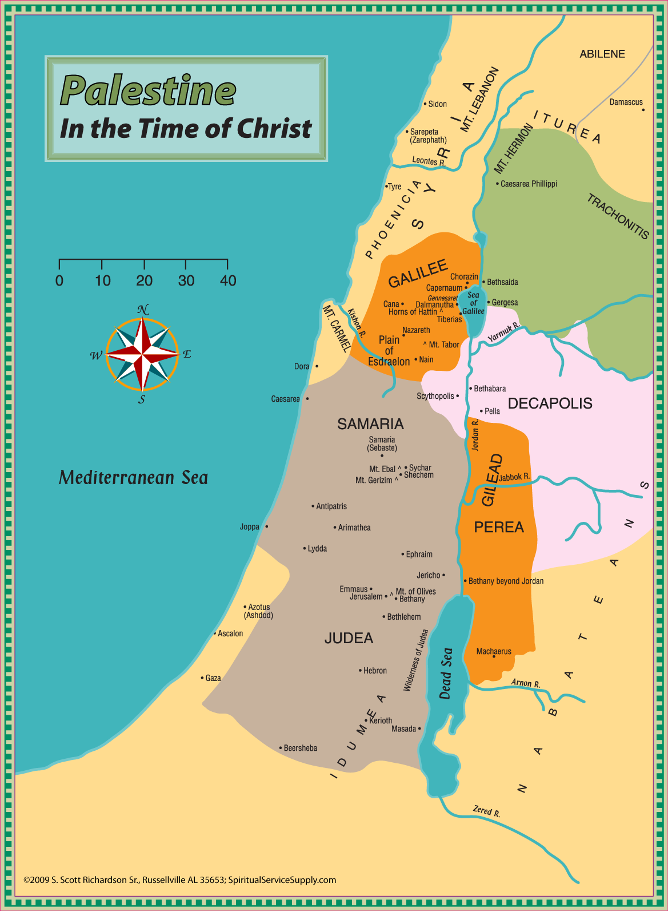

Jerusalem
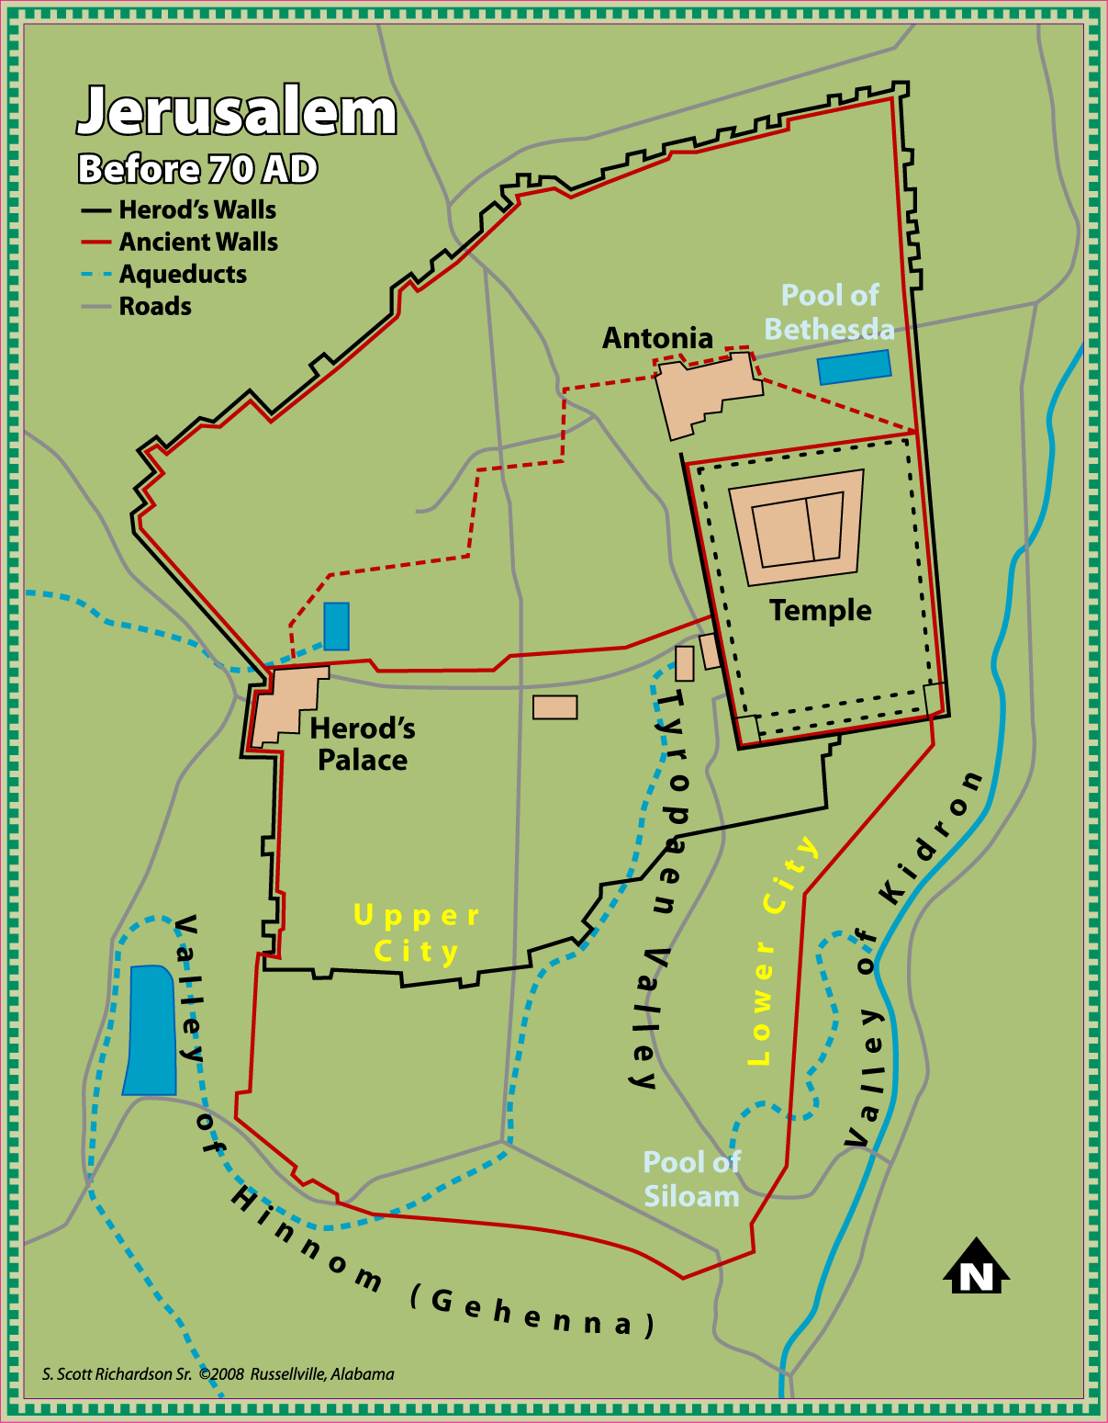

Remembrance Passages

Lessons 1-4
“And as they were eating, Jesus took bread, blessed and broke it, and gave it to them and said, ‘Take, eat; this is My body.’ Then He took the cup, and when He had given thanks He gave it to them, and they all drank from it. And He said to them, ‘This is My blood of the new covenant, which is shed for many.’ ” Mark 14:22-24.
Lessons 5-8
“Now on the first day of the week, very early in the morning, they, and certain other women with them, came to the tomb….But they found the stone rolled away from the tomb. Then they went in and did not find the body of the Lord Jesus. And it happened,…that behold, two men stood by them in shining garments. Then,…they said to them, ‘Why do you seek the living among the dead? He is not here, but is risen!’ ” Luke 24:1-6
Lessons 9-13
“And Jesus came and spoke to them, saying, ‘All authority has been given to Me in heaven and on earth. Go therefore and make disciples of all the nations, baptizing them in the name of the Father and of the Son and of the Holy Spirit, teaching them to observe all things that I have commanded you; and lo, I am with you always, even to the end of the age.’ ” Matthew 28:18-20

Lesson One: Jesus Rides into Jerusalem

Matt. 21, 22 (Mark 11:1—12:37; Luke 19:28—20:44; John 12:12-19)

- Please note that the passages in parentheses will be parallel texts that are not “required” reading for the lessons and if a question is taken from outside the primary text it will be noted, but these additional readings will enhance your understanding of the events.
- How did Jesus obtain the donkey colt on which He rode into Jerusalem?
- What Old Testament prophet had spoken of the King riding upon a donkey?
- How did the multitudes welcome Jesus to Jerusalem?
- What did the word Hosanna mean?
- Jesus accused some of turning what should have been a house of ______________ in to a ___________ of _______________.
- What caused Jesus to quote from Psalm 8 in speaking to the chief priests and scribes?
- Why did Jesus curse the fig tree?
- How did Jesus respond to the question about His authority for doing what He had done?
- Why were His questioners unwilling to answer Jesus’ question to them?
- Why were tax collectors and harlots going to enter the kingdom God before the chief priests and elders?
- List the different wicked things the vinedressers (husbandmen, tenants) when the landowner sought to receive his fruit.

- How would the owner respond to the killing of his son?
- Why did the chief priests and Pharisees not arrest Jesus at this time?
- What did those invited to the wedding do that angered the king?
- Who replaced those originally invited to the wedding feast?
- Why was the one man cast out?
- With whom did the Pharisees align themselves when they questioned Jesus about paying taxes?
- It was proper to give the tax money to Caesar because it bore the image of ______________.
- Whose image do we bear? To whom should we be given?
- Locate the Old Testament instructions about a man marrying his brother’s wife if his brother died without an heir.
- What two things did Jesus tell the Sadducees they didn’t know?
- On what two commandments did the Law and the Prophets hang?
- What psalm did Jesus quote in His question about David calling the Messiah Lord?

Lesson Two: Jesus Looks into Our Hearts

Matt. 23; Mark 12:41-44 (Mark 12:38-40; Luke 20:45—21:4)

- What was a scribe?
- Where did the scribes and Pharisees sit? What did Jesus mean by this?

- What did the scribes and Pharisees do with heavy burdens?
- They did their works to be seen of _______________. Cf. Matt. 6:1-18.
- What were phylacteries?
- Why did Jesus tell His disciples they should not be called Teacher or Father?
- The greatest in God’s kingdom is the one who is a ___________________.
- Define the word hypocrite.
- Note on 23:14. Because some manuscripts omit this verse it is not included in the ESV, but all the manuscript evidence and translations include the devouring of widows’ houses in Mark 12:40.
- What is a proselyte?
- Which oaths did the scribes and Pharisees consider binding? Which ones were “nothing?”

- What did they neglect even as they tithed their garden herbs?
- They would strain out a ____________ and swallow a ___________________.
- First cleanse the __________________ of the cup and dish.
- In what ways were the scribes and Pharisees like whitewashed tombs?
- What did the scribes and Pharisees say about the blood of the prophets?
- What things were going to come upon that generation?
- Jesus would have liked to have gathered the people of Jerusalem to Him as a _____________ gathers her ______________, but they were not willing.
- Where was Jesus when the widow cast in her two mites? (The quadrans or penny was worth about 1/64 of a denarius.)
- Why did Jesus praise this widow’s gift?

Lesson Three: Jesus Is Coming Again

Matthew 24 (Mark 13; Luke 21:5-38)

- Matthew 24 and its parallels are often misunderstood and misapplied to current events, but we need to recognize that there are some guideposts to understanding the text.
- What prompted this discourse on the Mount of Olives? 24:1-3
- When was everything in the first 33 verses to take place? 24:34
- While the first part of the chapter focuses on Jerusalem and Judea’s punishment at the hands of the Roman armies (24:2, 16; Luke 21:20-21), Jesus does seem transition to speaking of the time when He would return as the Judge to both reward and punish.
- In conjunction with Matt. 24 it is helpful to read 23:32-39.
- Why were they not to be troubled when they heard of wars and rumors of wars?
- What would cause the love of many to grow cold?
- Before “the end” could come, what had to happen with the gospel?
- When were those in Judea to flee to the mountains? Cf. Luke 20:20-21.
- In seeking to understand 24:29-30 it will be helpful to look at the way similar language was used in some Old Testament prophecies.
- Isaiah 13 is burden (oracle) against ________________. 13:1
- Who would be stirred up against Babylon? 13:17
- What would happen to the sun, moon, and stars in Isa. 13?
- Ezekiel 32 is said to contain a lamentation for what man? 32:1, 2
- What would happen to the sun and moon? 32:7-8
- What were they to learn from the fig tree?
- Jesus compared His coming in judgment to the days of _______________ when people were going about their normal routines until the ________________ took them away.
- Why is it important to always be watching?
- What happens to the servant who thinks His master’s return has been delayed and doesn’t conduct himself as he should?

Lesson Four: Jesus Wants Us to Be Ready

Matthew 25

- First-century weddings involved a number of celebratory events, one of which was a torch or lamp light procession through the streets.
- What did the five wise virgins do differently from the five foolish ones?
- When did the bridegroom finally come?
- What did the five unprepared virgins ask of the others?
- What happened when the five foolish virgins made it to the wedding?
- Since we do not know the day nor the hour of His coming, we should ________________.
- In the Parable of the Talents keep in mind that one talent was equal to 6,000 denarii.
- How did the lord (master) of the servants determine how much he would entrust each with?
- What did the three servants do with the talents entrusted to them?
- How long was the master away?
- How did the master reward the first two servants?
- How did the third servant seek to explain his failure to properly manage the money given him?
- His lord called him a _________________ and ________________ servant.
- What was done to the unprofitable servant?
- Who will be gathered before the Son of Man when He comes in His glory?
- Why were some allowed to inherit the kingdom prepared for them from the foundation of the world?
- Why were others sent away into the everlasting fire?
- For whom had the everlasting fire been prepared?

Lesson Five: Jesus Serves Others

John 13, 14; Matthew 26:17-25; Mark 14:17-21

- When we picture Jesus and His apostles at the table, we should not see a table like that in da Vinci’s The Last Supper. With first-century tables people usually reclined on cushions with their feet behind them. If we can visualize them in this way it will help us understand how Jesus could go around the table washing their feet, and also how John could lean back on Jesus (13:25).
- How did Peter react when Jesus came to him to wash his feet?
- Why didn’t Peter need his hands and head washed?
- What was Jesus seeking to teach the disciples by washing their feet?
- Jesus quoted Psa. ________ and said one who ate ___________ with Him would lift his heel against Him.
- How did the disciples react when Jesus told them one of them would betray Him?
- Which apostle asked Jesus who would betray Him?
- How did Jesus answer the question?
- What did the others think Jesus was telling Judas to do when He said, “What you do, do quickly”?
- What “new commandment” did Jesus give the apostles?
- Why were they not to allow their hearts to be troubled?
- What did Thomas ask when Jesus told them they knew the way?
- What was the reply of Jesus?
- Philip requested that Jesus show them __________________.
- Jesus replied, “He who has seen ______________ has seen ______________________.”
- Those who love Jesus keep His _____________________.
- The apostles were promised another ____________________, the Spirit of truth.
- The Holy Spirit would teach them ________________, and bring to their _________________ all things that Jesus had said to them.

Lesson Six: Jesus Prepares the Apostles

John 15-17

- This lesson continues Jesus’ discussion with the apostles the night of His betrayal and concludes with the longest recorded prayer of Jesus.
- Jesus called Himself the _______________ and the Father the _______________.
- What did a branch have to do if it was going to bear fruit?
- Jesus told them to abide in _______________ and let ________________ abide in them.
- The apostles were commanded to love another in what way or by what standard?
- Greater love has no one than to do what?
- How does one demonstrate that he is a friend to Jesus?
- Why would the world hate the apostles?
- Why had Jesus told them in advance about the hatred and persecutions they would face?
- When the Holy Spirit had come He would convict the world of what three things?
- The Holy Spirit would guide the apostles into __________ _______________.
- When would their sorrow be turned to joy?
- They could be of good cheer because Jesus had overcome _____________________.
- Jesus prayed that the Father ______________ Him, that He might _________________ the Father.
- The Lord prayed that His apostles be kept from _____________________.
- By what would they be sanctified?
- Who was Jesus praying for when He spoke of those who would believe on Him through the words of the apostles?
- What type of unity did Jesus ask that these believers have?

Lesson Seven: Jesus Is Betrayed

Matthew 26:1-16, 26-35; John 12:1-8; Luke 22:7-38 (Mark 14:1-16, 22-31; Luke 22:1-6)

- The anointing of Jesus probably took place in Bethany before the “Triumphal Entry.” John 12
- The supper at which Jesus was anointed took place in the house of what man?
- Why did the disciples complain about what Mary had done? What special motivation did Judas have in his criticism?

- Why did the leaders of the Jews think they would be unable to have Jesus killed during the Passover feast?
- What did Judas receive for betraying Jesus?
- Which two disciples prepared the Passover for Jesus and the others?
- How did they know which house to use?
- What would the bread and cup signify in the future?
- The blood of the __________ covenant would be shed for what purpose?
- What dispute arose among the apostles that night?
- How did Peter respond when Jesus told His disciples that all of them would be made to stumble that night?
- Peter would deny the Lord _______________ times before the rooster ________________.
- What was Peter to do after had returned to Jesus?
- Jesus had sent the apostles on a preaching journey before (Matt. 10; Luke 9), but what were they to do differently on their future journeys?

Lesson Eight: Jesus Is Arrested

Matthew 26:36—27:10 (Mark 14:32-72; Luke 22:39-71; John 18:1-27)

- What Old Testament character crossed the Brook Kidron and ascended the Mount of Olives as he left Jerusalem in sorrow?
- How did Jesus describe the sorrow He felt?
- What did Jesus pray when He separated Himself from Peter, James, and John?
- What did the three apostles do each time Jesus left them to go pray?
- Why was it so important that they watch and pray?
- How did Judas identify Jesus for those who had come to arrest Him?
- What did Peter do with the sword he had drawn?
- Jesus told Peter to put away the sword because…
- Those who _____________ the sword will ______________ by the sword.
- He could have called ________________________ angels if He so desired.
- The Lord asked why they had come out to arrest Him as though He was a _______________, when He had openly taught in the ___________________.
- What did all the disciples do when Jesus was placed under arrest?
- How did Peter gain admission to the courtyard of the high priest? John 18:15-18
- What was Jesus falsely accused of saying (26:61)? What had He actually said that was similar to the false accusation? John 2:13-22
- What bold statement by Jesus led the high priest to tear his clothes and accuse Jesus of blasphemy?
- What shameful things did they do to Jesus after pronouncing Him worthy of death? Cf. Mark 14:65.
- How many times did Peter deny knowing Jesus?
- What did he do after the rooster crowed?
- Why did Judas seek to return the thirty pieces of silver?
- Why was it not lawful to put the money into the treasury? What was done with it?

Lesson Nine: Jesus’ Trials

Luke 22:66—23:25; John 18:28—19:16 (Matthew 27:11-31; Mark 15:1-20)

- Though Jesus had appeared before the council during the night, Luke 22:66 (cf. Matt. 27:1-2) appears to have been a meeting held in order to pronounce the “official” condemnation.
- What charges did the Jews make against Jesus when they went to Pilate, the Roman governor?
- Why did the Jewish leaders not go into the Praetorium (governor’s headquarters)?
- What was the response of the Jews when Pilate told them to judge Jesus according to their own law?
- Why did the servants of Jesus not fight to keep Him from being delivered to the Jews?
- “Everyone who is of the _____________ hears My voice.”
- Pilate’s initial assessment was, “I find _________________ in Him.”
- Why was Jesus sent from Pilate to Herod?
- Why was Herod glad to see Jesus?
- What did Herod and his men do to Jesus before sending Him back to Pilate?
- What crimes had Barabbas committed?
- Why did Pilate’s wife not want him to be involved with Jesus? Matt. 27:19
- Who persuaded the multitude to ask for the release of Barabbas? Matt. 27:20
- How did Pilate attempt to signify his lack of guilt in condemning an innocent Man?
- What did scourging involve?
- Cf. Matt. 27:27-31 with John 19:1-4 for a fuller picture of the mockery Jesus endured.
- When Pilate brought Jesus before the people in John 19:4-5 he seems to have been hoping the sight of a scourged Man wearing a crown of thorns would evoke some sympathy. Instead, it caused them to say Jesus was a blasphemer.
- What did Jesus say when Pilate said he had the power to release or crucify Jesus?
- “We have no king but _______________.”

Lesson Ten: Jesus Dies on the Cross

Matthew 27:32-56; Mark 15:21-41; Luke 23:26-49; John 19:17-37

- Who was compelled to bear Jesus’ cross?
- For whom did Jesus tell the daughters of Jerusalem they should be weeping?
- What different names were given to the place where Jesus was crucified?
- What drink did Jesus refuse?
- What was done with the clothes the Lord had been wearing?
- Who was crucified along with Jesus?
- What did Pilate have placed over the head of Jesus? What change in wording did the chief priests want him to make?
- List the different ones said to have mocked Jesus at his crucifixion.
- What promise did the Lord make the one who asked to be remembered when He came into His kingdom?
- To whom did Jesus entrust the care of His mother?
- What happened about the sixth hour?
- The words of Matt. 22:46 (and Mark 15:34) are also the opening words of what psalm?
- When Jesus said, “I thirst,” He was given ___________________.
- The last words of Jesus on the cross were, “It is ________________,” and “Father, ‘into Your _______________ I commit My ______________.’ ”
- What happened to the veil of the temple that day?
- Why did the Jews want the legs of the crucified to be broken? Why didn’t they break the legs of Jesus?
- What happened when the soldier pierced the side of Jesus with his spear?
- When Jesus died the ____________ quaked, ________________ were split, and ________________ were opened.
- Who was said to have watched the crucifixion from afar?

Lesson Eleven: Jesus Rises from the Dead

Matthew 27:57—28:15; Mark 15:42—16:11; Luke 23:50—24:12; John 19:38—20:18

- Taking all the accounts together, what do we know about Joseph of Arimathea?
- Mark 15 describes Joseph as taking _______________ when he went to Pilate.
- What other man assisted Joseph in the burial of Jesus?
- In what tomb was Jesus laid? Cf. Isaiah 53:9.
- Who was said to have observed the place where they buried Him?
- Why did the Jews want the tomb want the tomb secured until the third day?
- What was done to secure it?
- Who were the first people to visit the tomb on resurrection day?
- What was their concern as they approached the tomb?
- What were they asked by the two “men” in shining garments?
- Who ran to tell Peter and John about the empty tomb?
- What was Mary Magdalene doing when Jesus appeared to her?
- How did Mary Magdalene come to recognize Jesus?
- When did Jesus appear to the other women?
- Why were the tomb guards given a large sum of money?

Lesson Twelve: Jesus Lives!

Luke 24:13-35; John 20:19—21:25

- Jesus joined two men as they walked toward the village of _____________________.
- What question did Cleopas ask when Jesus inquired as why they were so sad?
- What did some of Cleopas’ company find when they went to the tomb where Jesus had been laid?
- Jesus explained that the Christ had to ______________ and to enter into His _______________.
- When did the two men realize they were talking to Jesus?
- Where did the two men go after Jesus vanished?
- Why were the disciples meeting behind closed doors the evening of the resurrection?
- What did Jesus show them so that they might know it was really Him?
- What did Thomas say would have to happen before he would believe?
- When Jesus appeared to him, Thomas said, “My _____________ and my ______________.”
- Though Jesus had done many other signs, why were the ones selected preserved for us?
- By what other names was the Sea of Tiberias known?
- How many fish did the seven disciples catch the night before Jesus appeared to them on the shore?
- When did John realize it was the Lord giving them instructions?
- What did Peter do when he realized it was Jesus?
- How many fish did they catch when they cast the net at the instructions of Jesus?
- Peter was asked _____________ times if he loved Jesus.
- How did Jesus respond to each of Peter’s affirmatives?
- What would happen to Peter when he was old?
- How did the Lord reply to Peter’s question about what would happen to John?

Lesson Thirteen: Jesus Returns to Heaven

Matthew 28:16-20; Mark 16:14-20; Luke 24:36-53; Acts 1:1-11

- Luke 24:36-43 takes us back to the night of the resurrection. How did Jesus convince the disciples He was not a spirit?
- Where were the apostles to go and preach the gospel?
- Of whom were they to make disciples (teach—KJV)?
- How much authority did Jesus claim He had?
- Disciples were expected to observe what commandments?
- Who would be saved and who would be condemned?
- What signs would be performed to prove the claims of the apostles?
- Jesus told His apostles that all things written in the ________________ and the ________________ and the _________________ had to be fulfilled.
- What was to be preached in Jesus’ name to all nations? Luke 24
- How long did Jesus remain on earth after His resurrection?
- What were the apostles told to wait for in Jerusalem?
- They were to be His witnesses in __________________, __________________ and ________________, and to the _______________ of the earth.
- What was Jesus doing when He was taken up from the apostles?

